Real-Time Analytics in Microsoft Fabric
Introduction
Using a sample bicycle rental dataset, this lab walks through creating an event stream, transforming streaming events, storing enriched data in a KQL database, and creating alerts for operational monitoring.

Exercise 1: Environment Setup

Task 1: Create a Fabric workspace
- Open your browser, navigate to the address bar, and type or paste the following URL: https://app.fabric.microsoft.com/then press the Enter button and sign in with your credentials
- In the Workspaces pane, click on +New workspace tile
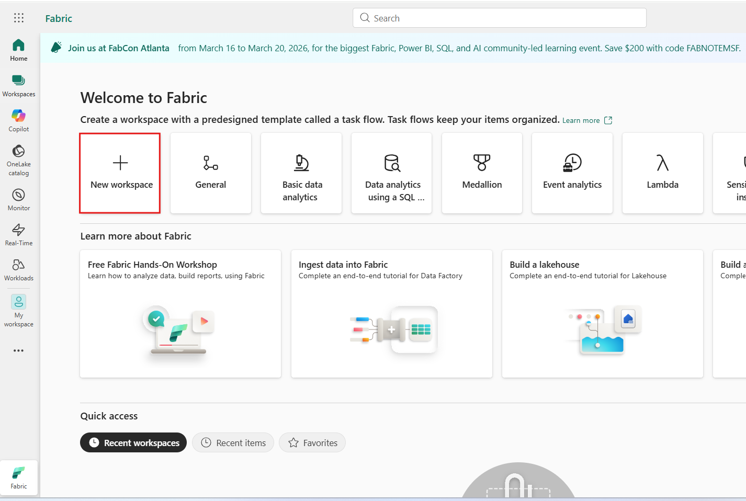
- In the Create a workspace pane that appears on the right side, enter the following details, and click on the Apply button.
Name | RTIWorkspaceXXX (XXX can be a unique number)
Advanced | Under License mode, select Fabric capacity
Default | storage format Small dataset storage format

Task 2: Create an eventhouse
- On the Workspace home page, select +New item and select Eventhouse under Store Data
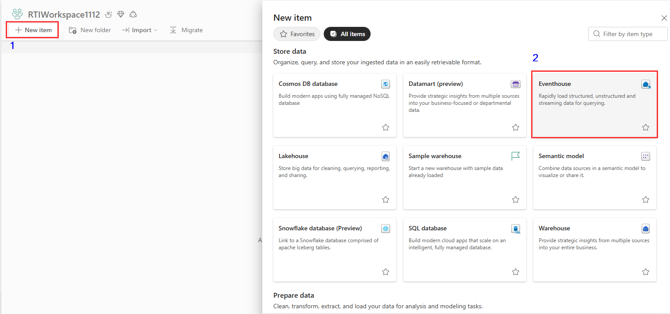
- Name the Eventhouse eh_RideWise and click on the Create button.
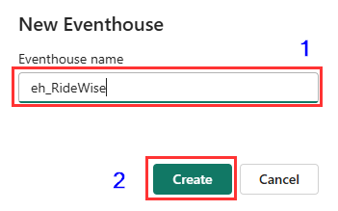
- When provisioning is complete, the eventhouse System overview page is shown.
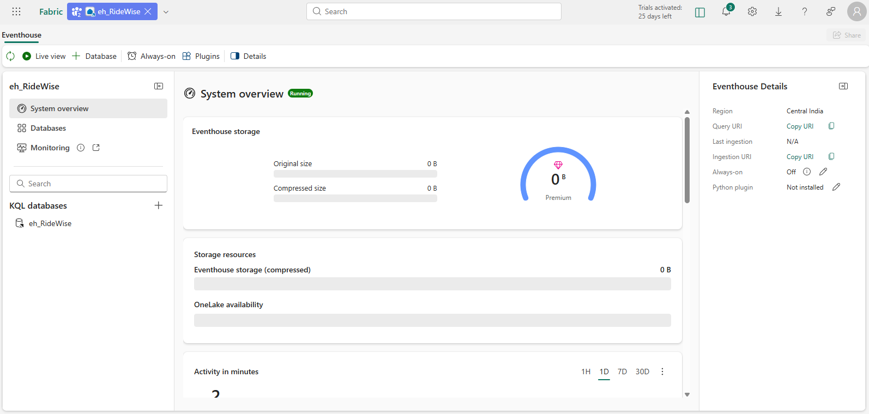

Exercise 2: Get data in the Real-Time hub

Task 1: Create an event stream
- From the eventhouse System overview page, select eh_RideWise database.
- In the eh_RideWise database page , Select the Get data
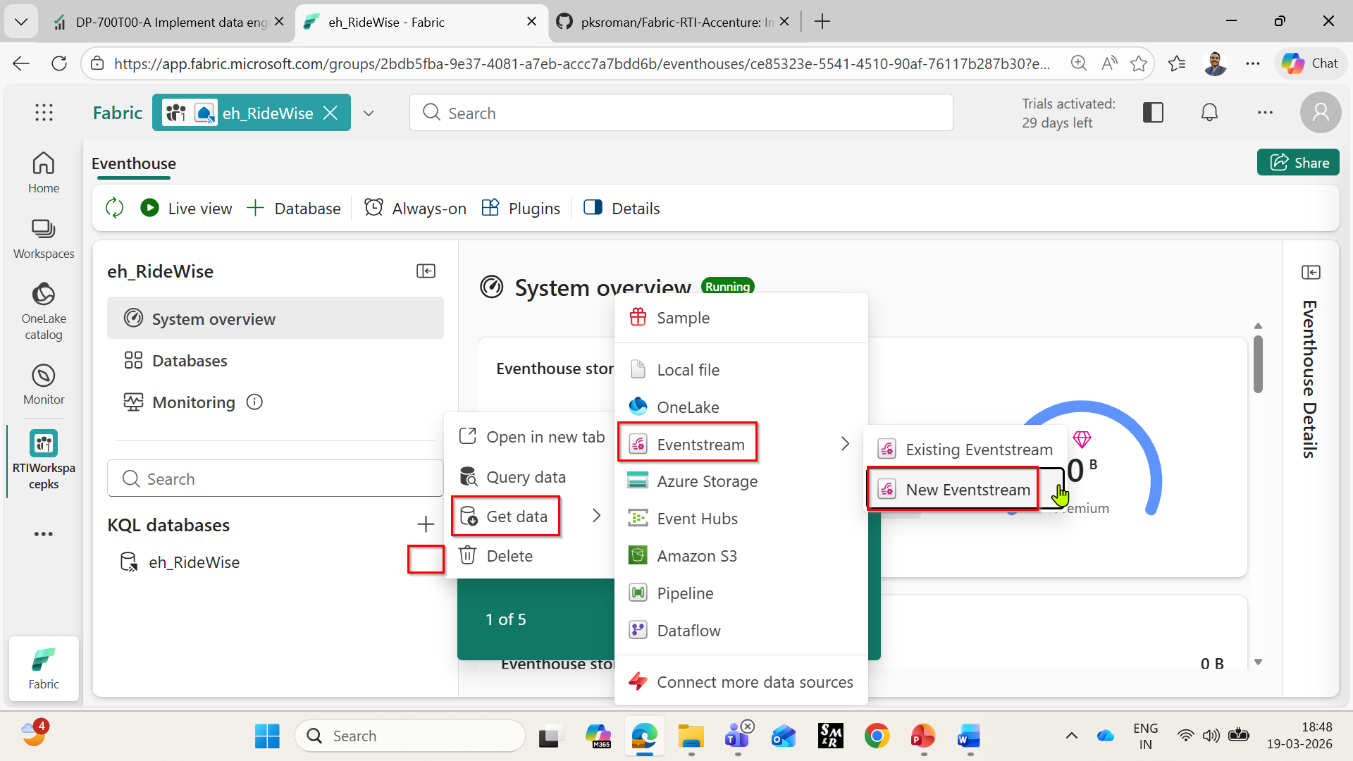
- On the New Eventstream Dialog, enter es_RideWise and click create.
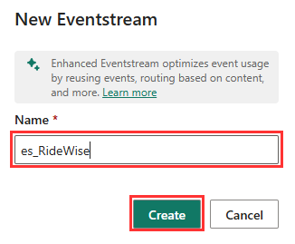
- In the es_RideWise eventstream page, Select the Use sample data.
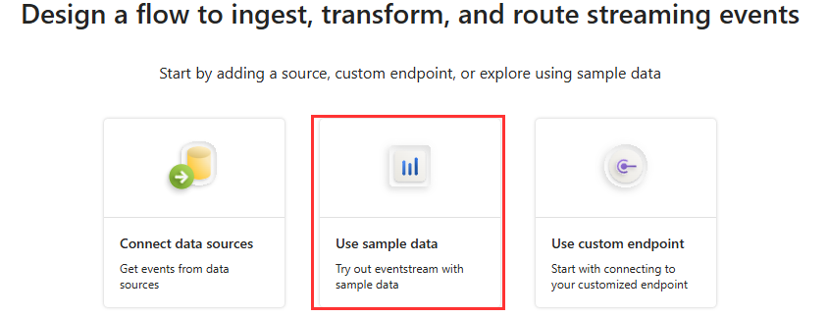
- In the add source page, Enter the Source name RideWiseSource and for the Sample Data Select Bicycles and click Add.
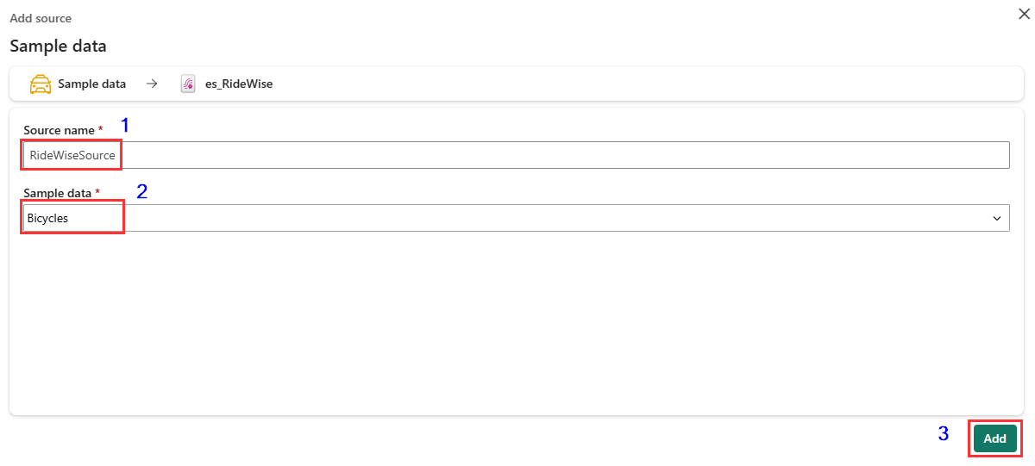
- Now, source will be added to your es_RideWise stream.
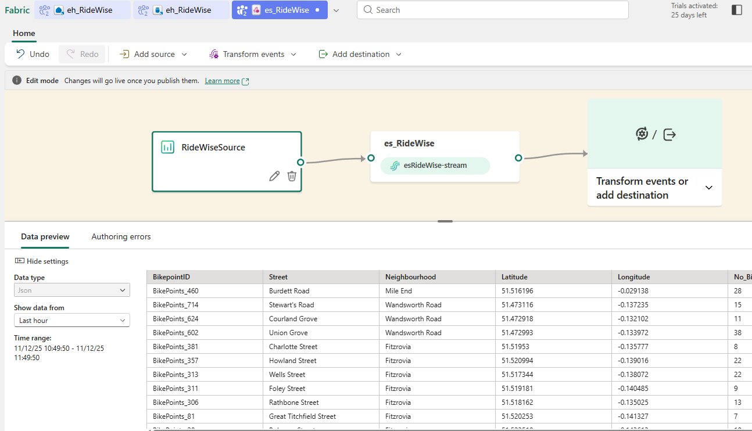

Task 2: Transform events
- In the Eventstream page, select Edit from the menu ribbon if it is in Live mode.
- In the event stream authoring canvas, select the down arrow on the Transform events or add destination tile. Select Manage fields.
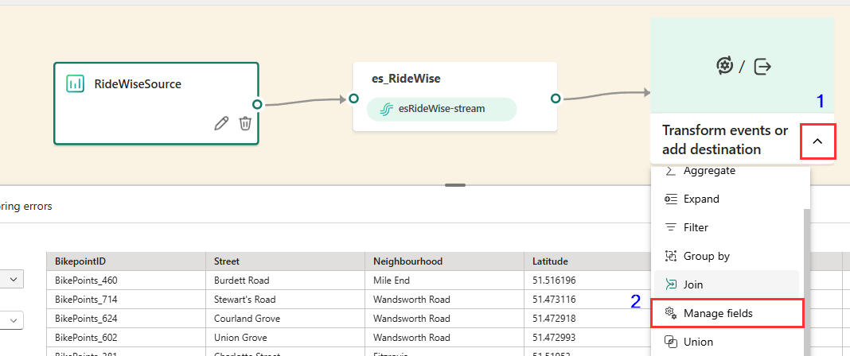
- Select the pencil icon on the ManageFields tile.
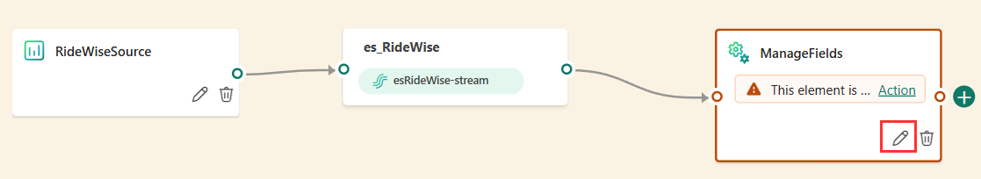
- In the Manage fields pane Select Add all fields.
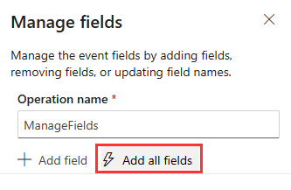
- In the Manage fields pane, Select + Add field.
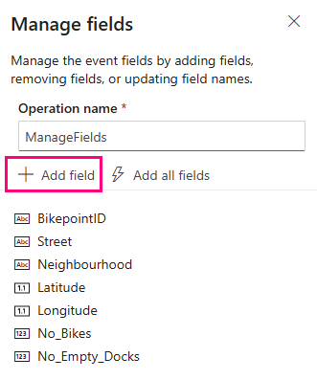
- In the Manage fields pane, dropdown the Field and from the Built-in Date Time Function dropdown, select SYSTEM.Timestamp()
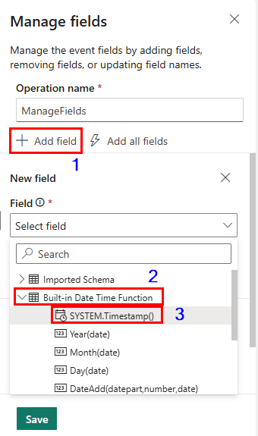
- Enter Timestamp as the Field name and Select Add.
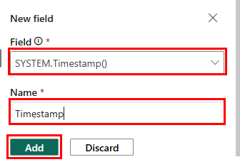

- In Manage fields tab, Select Save.

Task 3: Create a destination
- Hover over the right edge of the ManageFields tile and select the green plus icon.
- Select Destinations > Eventhouse.
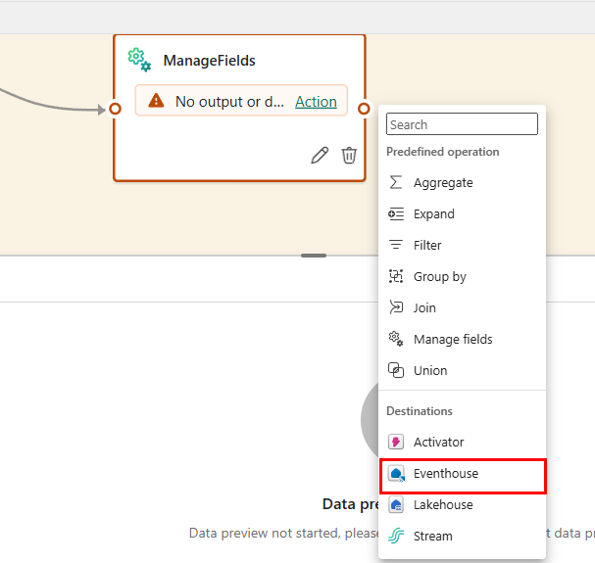
- On the new entitled Eventhouse Select the pencil icon
- Enter the following information in the Eventhouse pane and select the Save button.
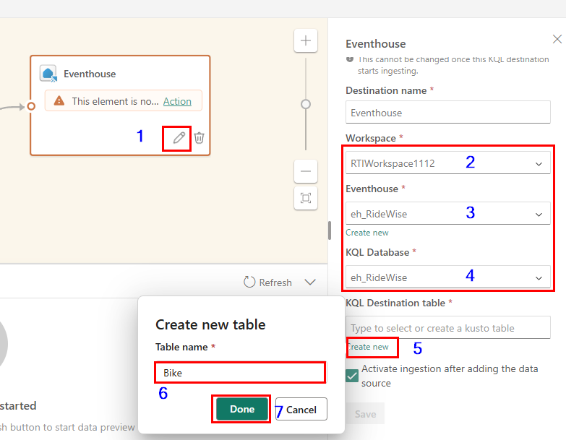
- From the menu ribbon, select Publish.
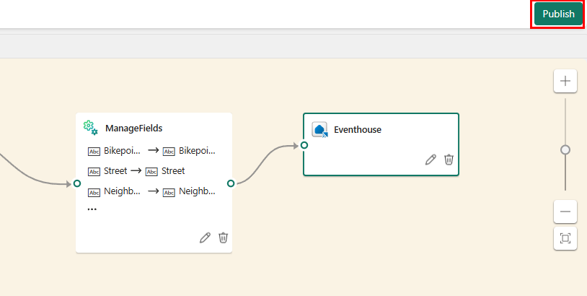
- The event stream is now set up to transform events and send them to a KQL database. Wait till the event stream start.
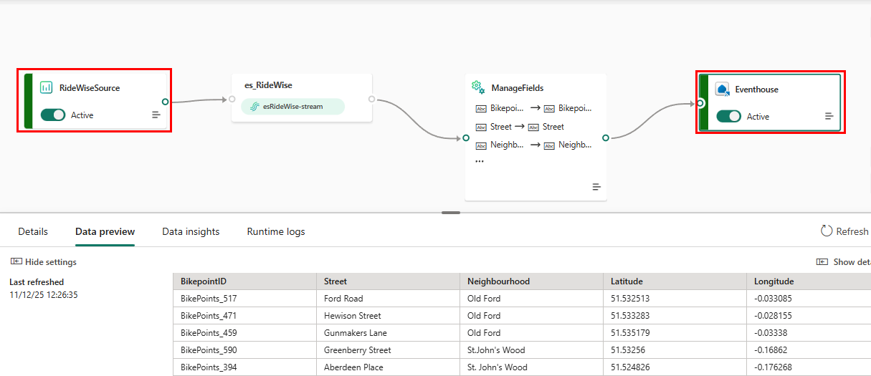

Exercise 3: Set an alert on your event stream

Task 1: Set an alert on the eventstream
- From the left navigation bar, select Real-Time.
- Select the eventstream you created in the previous exercise named esRideWise-stream. The eventstream details page opens.
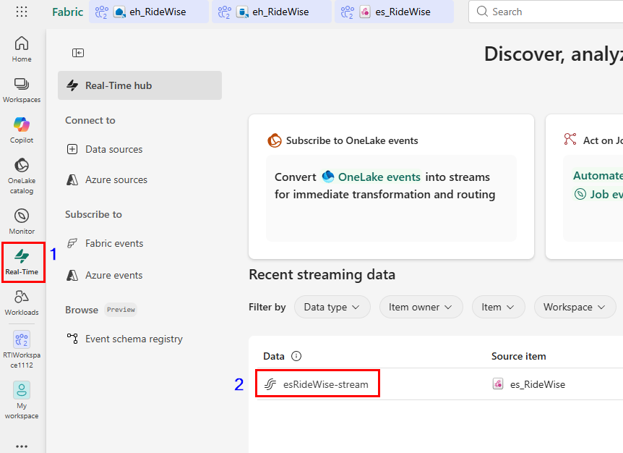
- Select Set alert
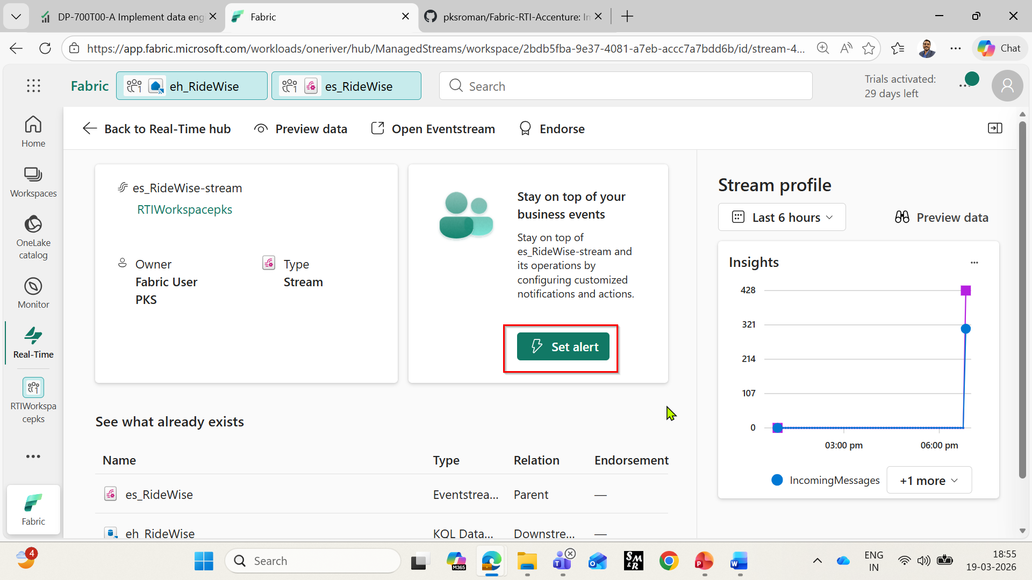

- A new pane opens. Fill in the fields as follows and select Create.
Field Details | Value
Rule name | RideWiseNoBikeRule
Condition
Check | On each event when
Field | No_Bikes
Operation | Is less than 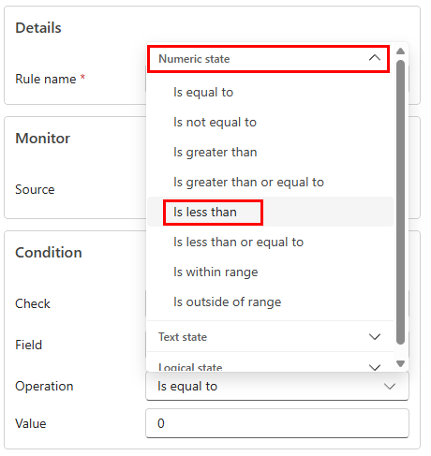  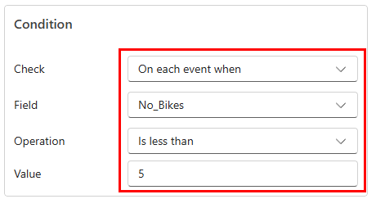
Value | 5
Action
Select action | Message to individuals
To | Your Teams account
Headline | Activator alert
Notes | The condition has been met
Context | No_Bikes
Save location
Workspace | The workspace in which you created resources
Item | Create a new item
New item name | No Bike Activator
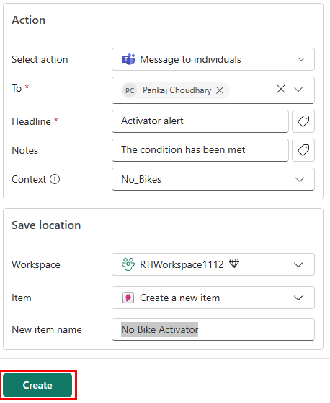
- The alert is set, and you receive a notification in Teams when the condition is met
- Click on Done
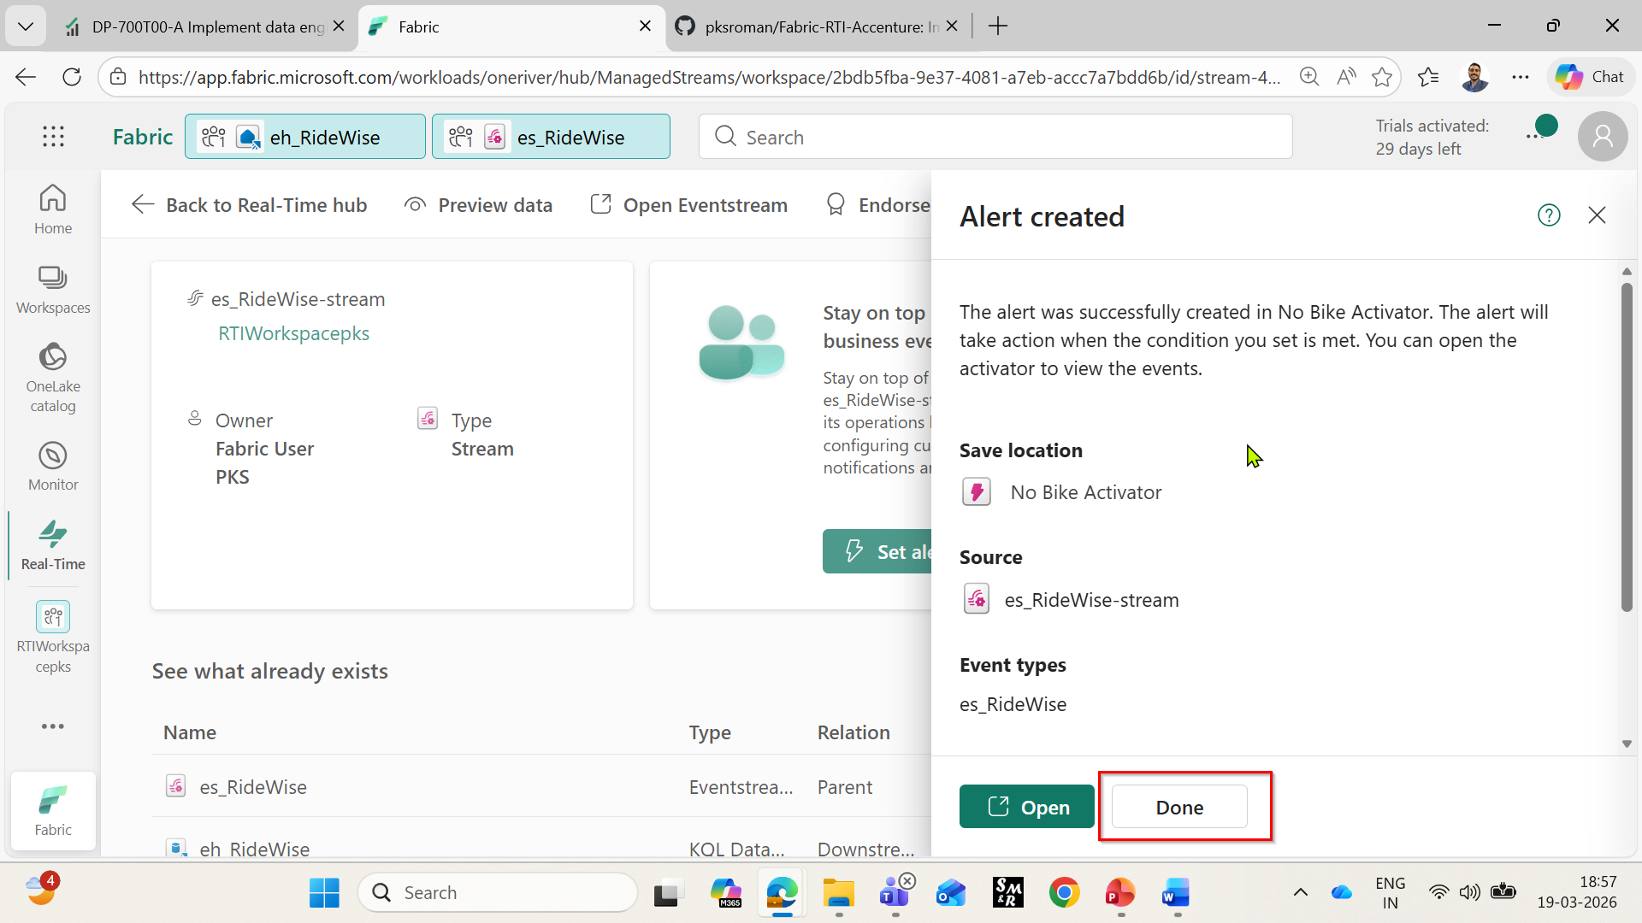

Exercise 4: Transform data in a KQL database
You will use an update policy to transform data in a KQL Database in Real-Time Intelligence. Update policies are automation mechanisms triggered when new data is written to a table.

Task 1: Move raw data table to a bronze folder
- Browse to your workspace RTIWorkspaceXXX and Select the KQL database eh_RideWise you created in a previous step.
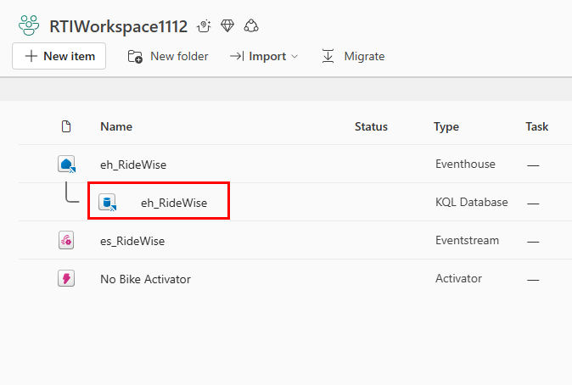
- In the database view select the eh_RideWise_queryset and click the + button to create a new KQL script.
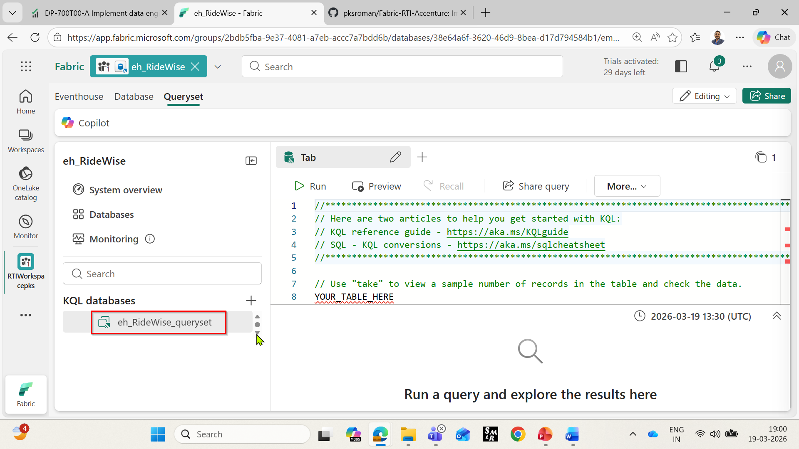

- Copy/paste the following code to alter the existing Bike table to be into the Bronze folder.
.alter table Bike (
BikepointID: string,
Street: string,
Neighbourhood: string,
Latitude: real,
Longitude: real,
No_Bikes: long,
No_Empty_Docks: long,
Timestamp: datetime)
with (folder="Bronze")

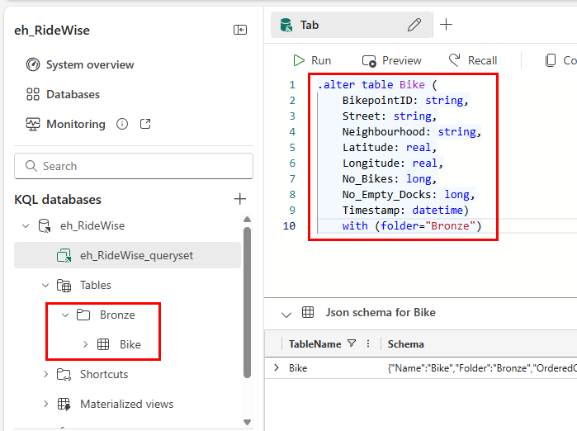

Task 2: Create target table in Silver Folder
- Create a new KQL script and copy/paste the following code to create a new table called TransformedData with a specified schema.
.create table TransformedData (
BikepointID: int,
Street: string,
Neighbourhood: string,
Latitude: real,
Longitude: real,
No_Bikes: long,
No_Empty_Docks: long,
Timestamp: datetime,
BikesToBeFilled: long,
Action: string)
with (folder="Silver")

- Run the command to create the table.
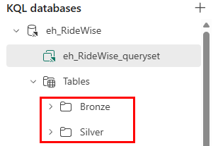

Task 3: Create function with transformation logic
Create a stored function that will be used in the update policy to apply the transformation.
- Inside eh_RideWise_queryset, select the + sign to create a new KQL script.
- Copy and paste the following code. This code creates a new function to parse the BikepointID column and generate two new calculated columns.
.create-or-alter function TransformRawData() {
Bike
| parse BikepointID with * "BikePoints_" BikepointID: int
| extend BikesToBeFilled = No_Empty_Docks - No_Bikes
| extend Action = iff(BikesToBeFilled > 0, tostring(BikesToBeFilled), "NA")
}

- Run the command to create the function. You should now see the function TransformRawData under the Functions node in the object tree
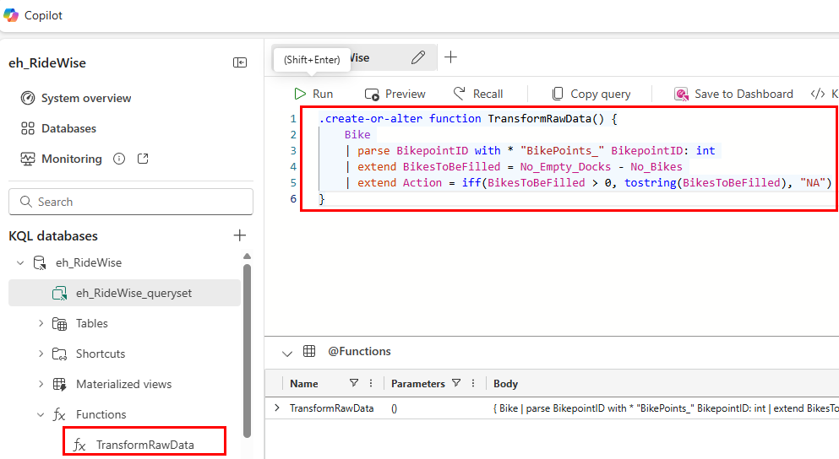

Task 4: Apply update policy
Apply update policy to the target table to transform the data. The update policy uses the stored function TransformRawData() to parse the BikepointID column and adds two new calculated columns.
- Inside eh_RideWise_queryset, select the + sign to create a new KQL script.
- From the menu ribbon, select Database and select + New > Table update policy.
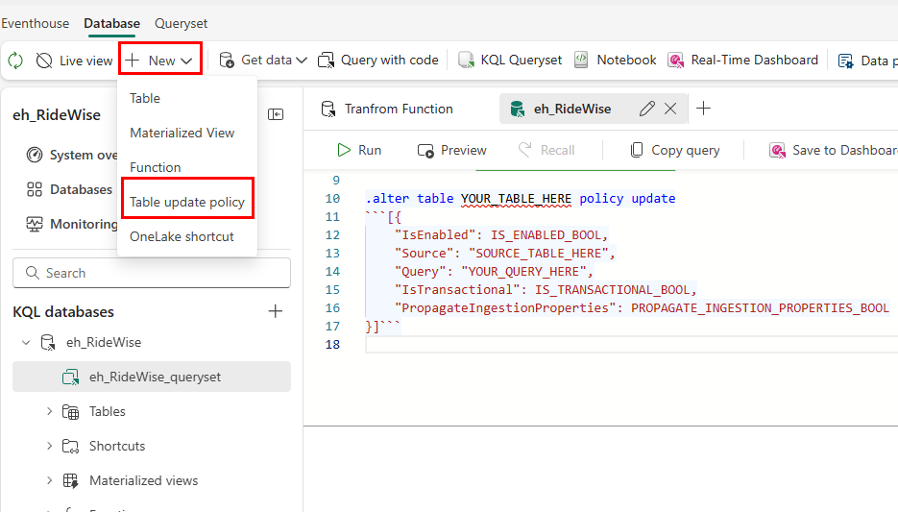

- Edit the policy so that it matches the following code and Run the command to apply the update policy.
.alter table TransformedData policy update
```[
{
"IsEnabled": true,
"Source": "Bike",
"Query": "TransformRawData()",
"IsTransactional": false,
"PropagateIngestionProperties": false
}
]```

Task 5: Verify transformation
Verify that the transformation was successful by comparing the output from the source and target tables. Note: It might take few seconds to see data in the transformed table.
- Create a new KQL script and copy/paste the following query to view 10 records from the RawData source table. Run the query.
Bike
| take 10
- Copy/paste the following query into a new KQL editor to view 10 records from the TransformedData target table. Run the query.
TransformedData
| take 10

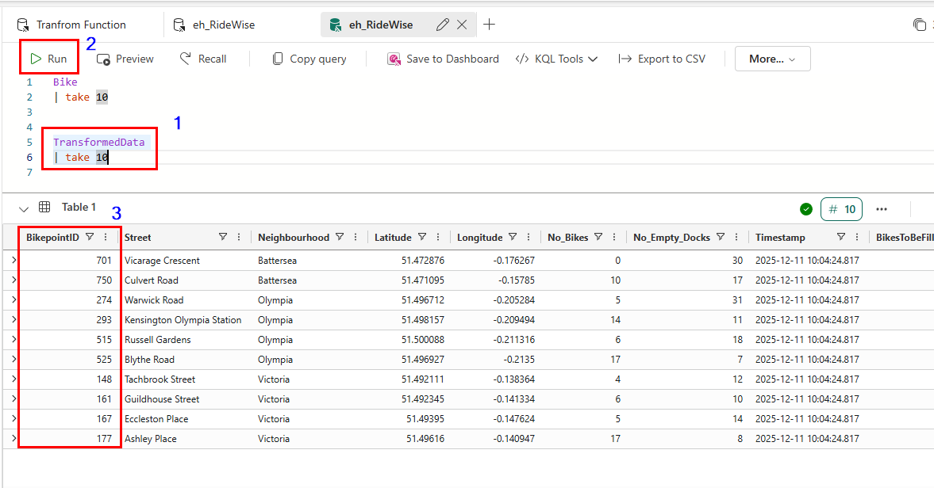
Notice that the BikepointID column in the target table no longer contains the prefix "BikePoints_".

Exercise 5: Query streaming data using KQL
Write a KQL query to visualize data in a time chart and create an aggregation query using a materialized view. You also query data by using T-SQL and by using explain to convert SQL to KQL.

Task 1: Write a KQL query
The name of the table you created in a previous step is TransformedData. Use this (case-sensitive) name as the data source for your query.
- In the Tutorial_queryset, enter the following query. Then press Shift + Enter to run the query.
TransformedData
| where BikepointID > 100 and Neighbourhood == " Victoria"
| project Timestamp, No_Bikes
| render timechart

This query creates a time chart that shows the number of bikes in the Victoria neighborhood as a time chart. Note that the visual output may vary based on the real-time data available.

Task 2: Create a materialized view
Create a materialized view, which returns an up-to-date result of the aggregation query. Querying a materialized view is faster than running the aggregation directly over the source table.
- Run the following command to create a materialized view that shows the most recent number of bikes at each bike station:
.create-or-alter materialized-view with (folder="Gold") AggregatedData on table TransformedData {
TransformedData
| summarize arg_max(Timestamp, No_Bikes) by BikepointID
}

- Run the following query to see the data in the materialized view visualized as a column chart:
AggregatedData
| sort by BikepointID
| render columnchart with (ycolumns=No_Bikes, xcolumn=BikepointID)

- The query editor supports the use of T-SQL. Enter the following query, and then press Shift + Enter to run the query.
SELECT top(10) *
FROM AggregatedData
ORDER BY No_Bikes DESC

- To get the equivalent KQL for a T-SQL SELECT statement, add the keyword explain before the query. Enter the following query. Then press Shift + Enter to run the query.
explain
SELECT top(10) *
FROM AggregatedData
ORDER BY No_Bikes DESC

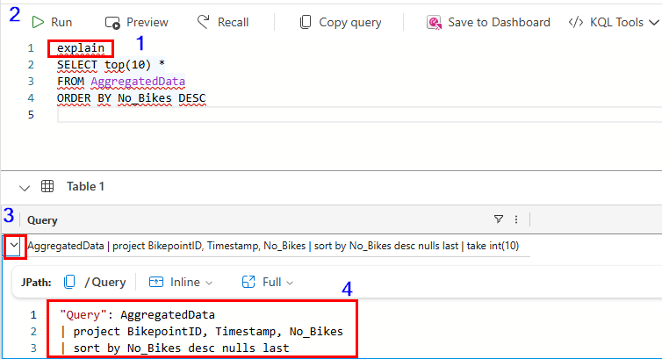

Task 3: Use Copilot to generate a KQL query
Ask a question in natural language and Copilot generates the KQL query for you.
- In the Menu bar, select Queryset then select Copilot.
- Enter a question in natural language.
- For example, Which station has the most bikes right now. Use the materialized view for the most updated data.
It can help to include the name of the materialized view in your question.
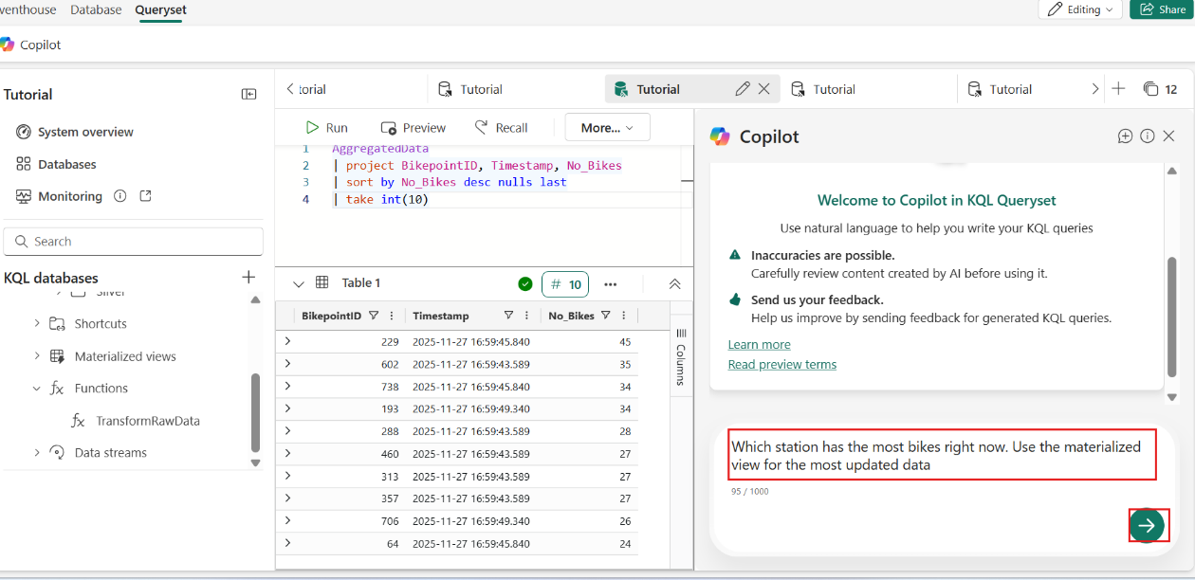
The Copilot suggests a query based on your question.
- Select the Insert button to add the query to the KQL editor.
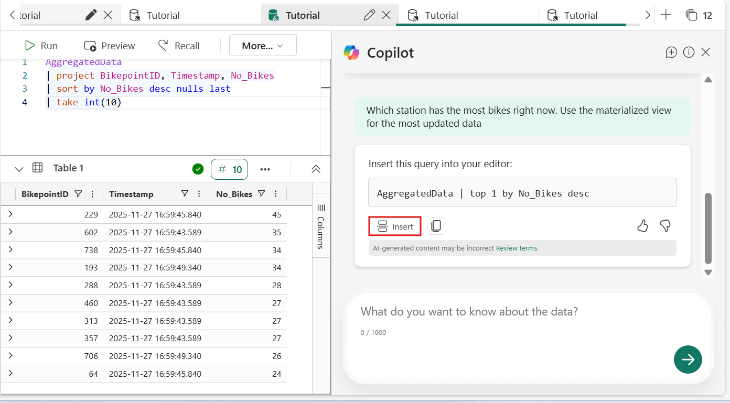
- Select Run to run the query.
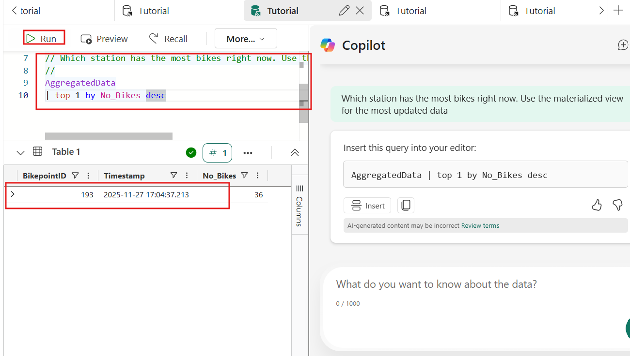
Ask follow-up questions or change the scope of your query. Use this feature to learn KQL and generate queries quickly.

Exercise 6: Create a Real-Time dashboard

Task 1: Create a Real-Time dashboard
- In your KQL queryset, copy/paste, and run the following query. This query returns a column chart showing the most recent number of bikes by BikepointID.
AggregatedData
| sort by BikepointID
| render columnchart with (ycolumns=No_Bikes, xcolumn=BikepointID)

- Select Save to dashboard and In a new dashboard.
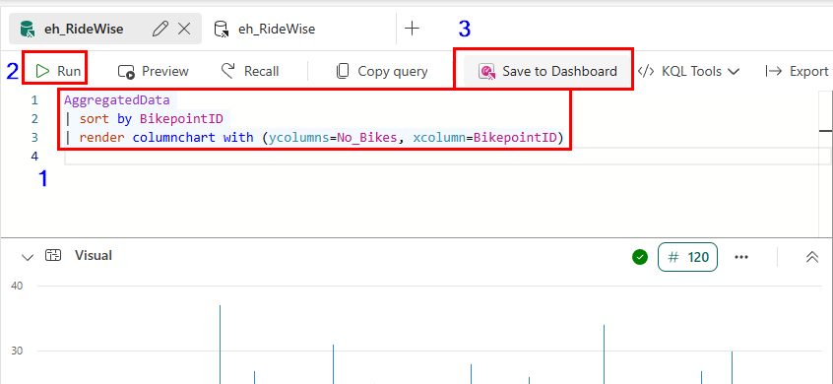
- Enter the following information and select Create.
Field | Value
Dashboard name | BikeRentalDashboard
Tile name | Recent bikes by Timepoint
Open dashboard after creation | Selected
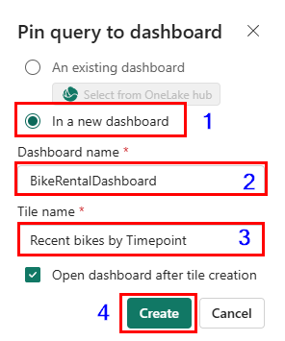

- Select RTIWorkspaceXXX in the left-sided navigation menu to return to the workspace item list and Select BikeRentalDashboard

Task 2: Add a new tile to the dashboard
- On the top menu bar, toggle from Viewing mode to Editing mode.
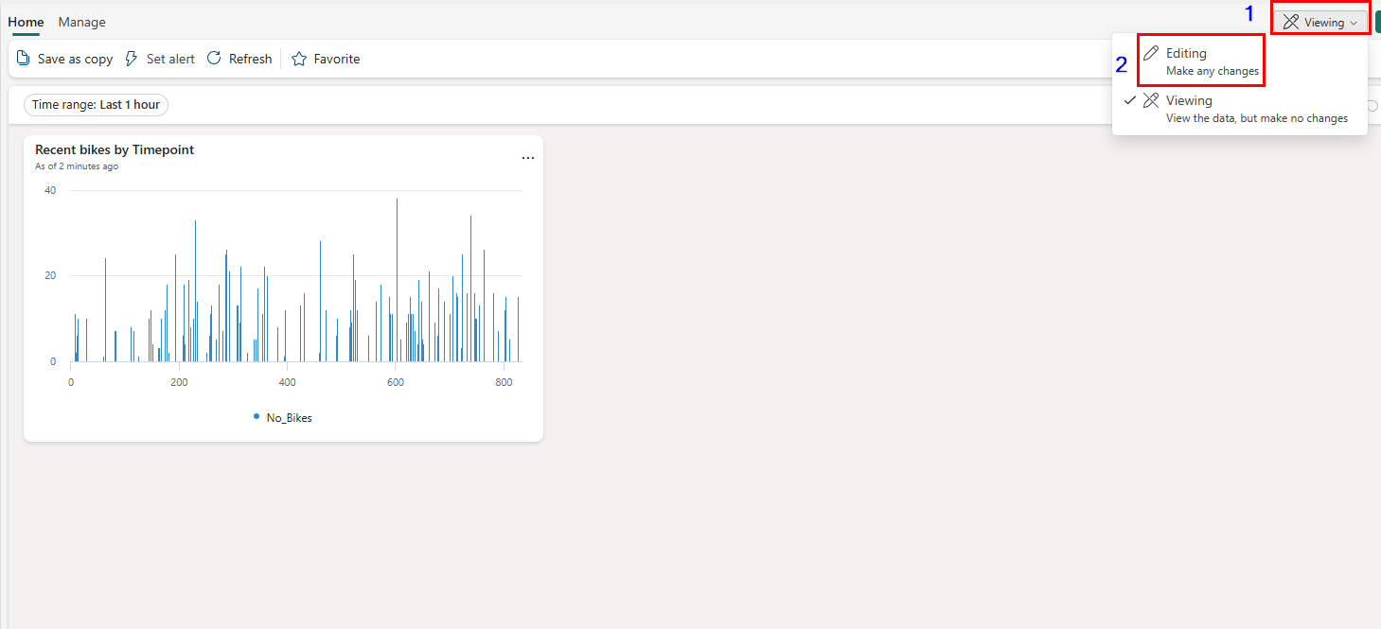
- Select New tile
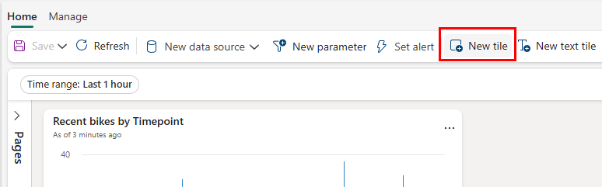
- In the query editor, enter and run the following query:
Bike
| where Timestamp > ago(1h)

- Above the results pane, select + Add visual.
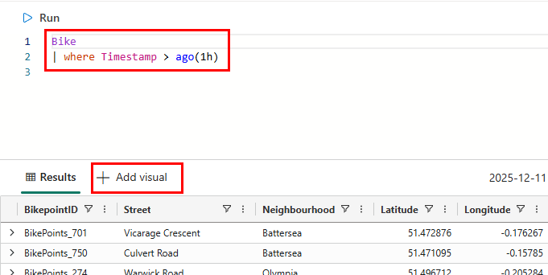
- In the Visual formatting pane, enter the following information:
Field | Value
Tile name | Bike locations Map
Visual type | Map
Define location by | Latitude and longitude
Latitude column | Latitude
Longitude column | Longitude
Label column | BikepointID
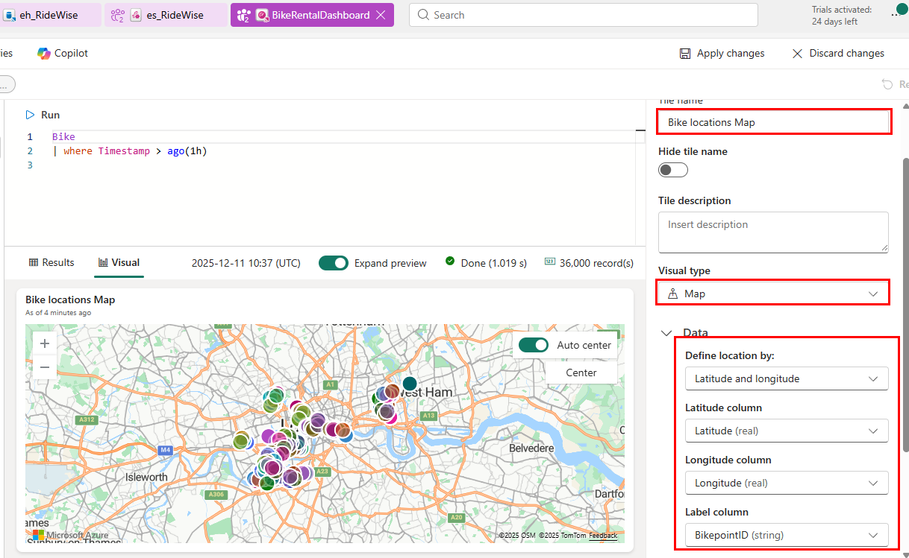
- Select Apply changes. You can resize the tiles and zoom in on the map as desired.
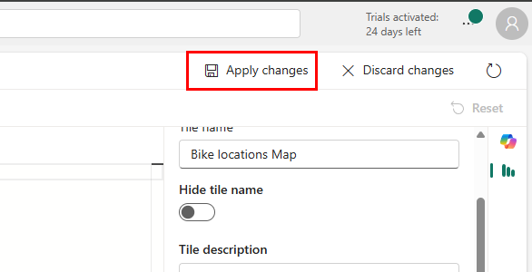

- Save the dashboard by selecting the Save icon on the top left corner of the dashboard.
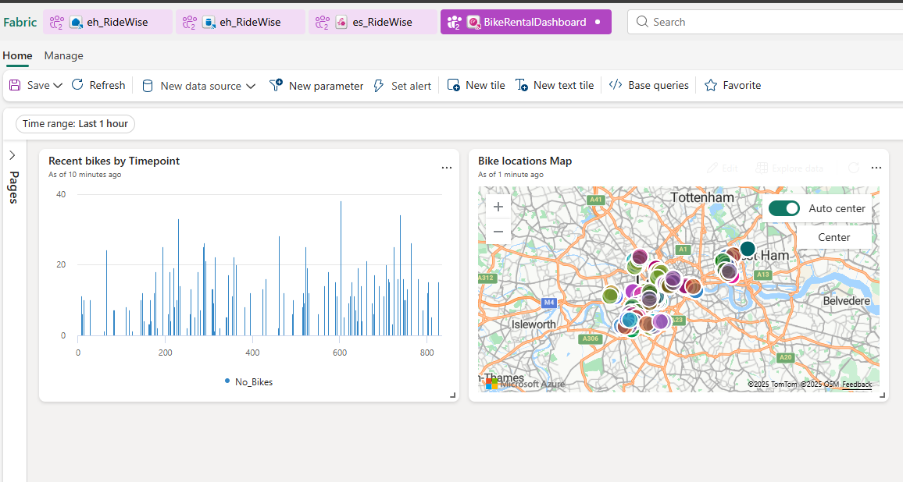

Exercise 7: Create Anomaly detection on your data
Anomaly detection is a feature of Real-Time Intelligence that allows you to identify unusual patterns in your data. In this part of the tutorial, you learn how to create an 'Anomaly detector' item on your workspace to detect anomalies in the number of empty docks at a station.

Task1: Detect anomalies on an Eventhouse table
- From the left navigation bar, select Real-Time to open the Real-Time hub.
- Under Recent streaming data select the eventhouse table TransformedData
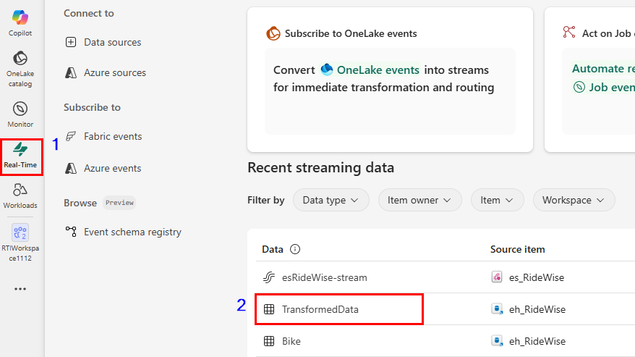

- The table details page opens. Select Detect anomalies from the top menu.
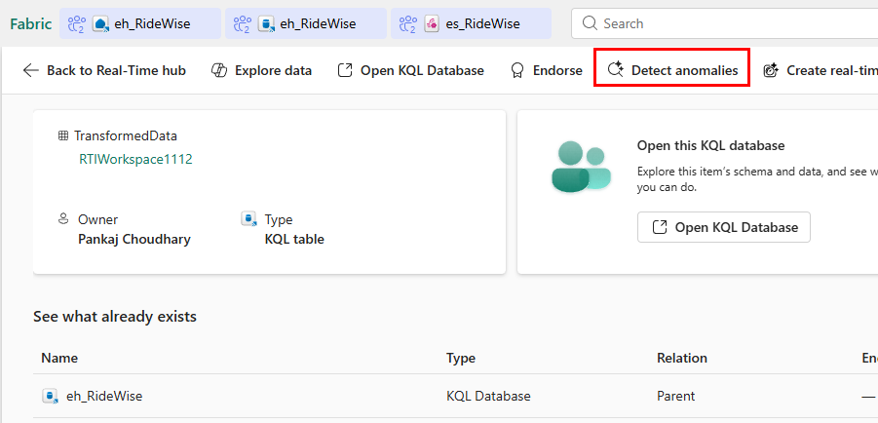
- Enter BikeAnomaliesconfiguration as Name. Under Save to, select the dropdown and choose Create detector.
- In the Create anomaly detector pane, select the RTIWorkspaceXXX to create the anomaly detector in, enter a name such as BikeAnomalies. Then select Create.
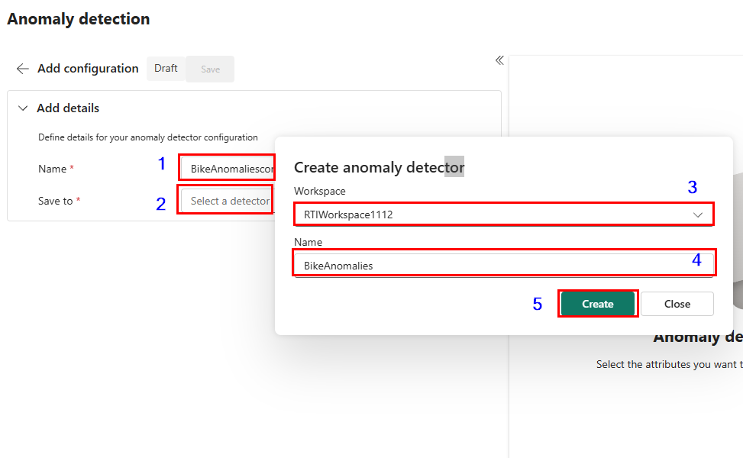
- In the Select attributes section, choose the following options and click on Run analysis.
Field | Value
Value to watch | No_Empty_Docks
Group by | Street
Timestamp | Timestamp
Click Save and Click Run Analysis
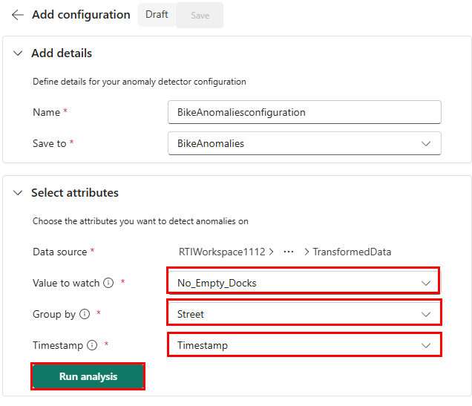
! IMPORTANT Analysis typically takes up to 4 minutes depending on your data size and can run for up to 30 minutes. You can navigate away from the page and check back in when the analysis is complete.
! NOTE Ensure your Eventhouse table contains sufficient historical data to improve model recommendations and anomaly detection accuracy.
- When analysis is complete, anomalies along with tabular data are displayed on the right.
Play around with the Detection model under Customize detection section and Timestamp above the Detector results pane. More data might increase anomaly detection accuracy.
- Select Save then select Publish.
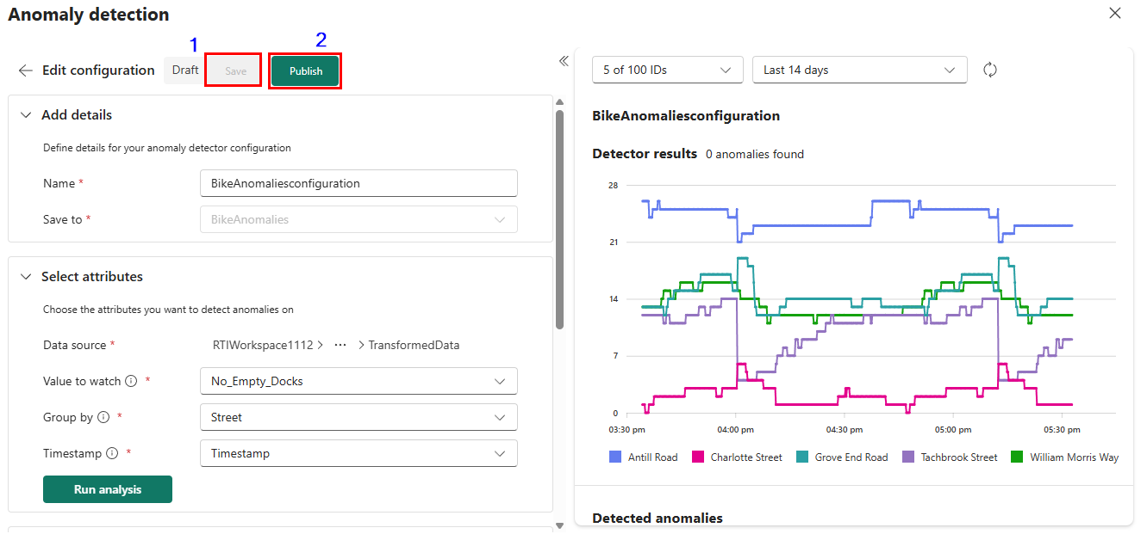

Task 2: Create anomaly alerts
Now that you have created an anomaly detector, you can create alerts to notify you when anomalies are detected.
- Select Real-Time from the left navigation bar to open the Real-Time hub and select Fabric events.
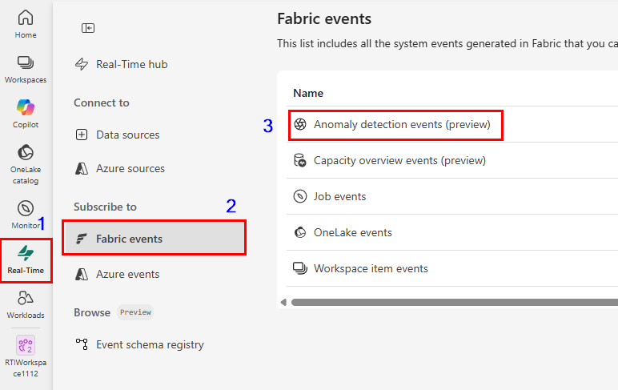
- Select Set alert on Anomaly detection events.
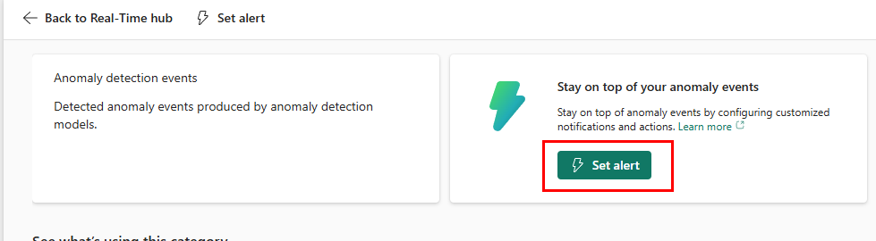
- From the side Add rule pane, use BikeAnomalyAlert as the Rule name.
- Under Monitor, click on Select source events and configure the following. Click Next button
Field | Value
Event type(s) | Microsoft.Fabric.AnomalyEvents.AnomalyDetected
Event scope | Select RTIWorkspaceXXX workspace from drop down
Item | Select Anomaly detector item you created in previous section BikeAnomalies
Configuration | Select configuration you created in previous section BikeAnomaliesconfiguration
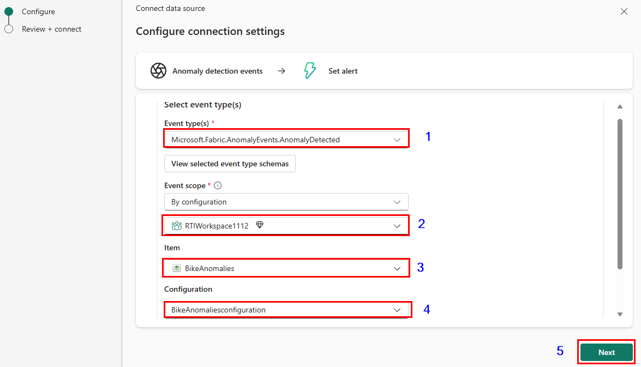

- Select Save
- Leave Condition as On each event .
- Configure the Action with the following details:
Field | Value
Select action | Message to individuals
To | User Email ID/Account
Headline | Anomaly detected in Bike Sharing Data
Notes | An anomaly has been detected in the bike sharing data. Please check.
Context | Select analysisType, timestampAttributeName, timestampAttributeValue, univariate, customAttributes
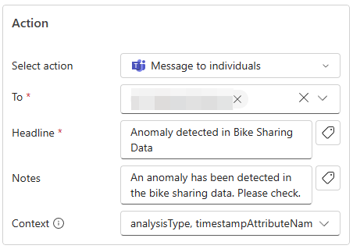
- Configure Save location with the following details:
Field | Value
Workspace | RTIWorkspaceXXX workspace from drop down
Item | Create a new item
New item name | AnomalyAlert
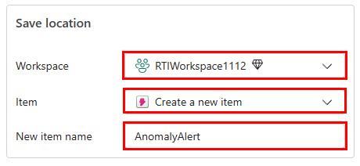
- Select Create to create the anomaly alert rule then select Done.

